Pokhara University

Level: Bachelor | Semester – Spring | Year : 2006
Programme: BE |  | Full Marks: 100
Course: Numerical Methods |  | Time : 3hrs.

Candidates are required to give their answers in their own words as far as practicable.
The figures in the margin indicate full marks.

Attempt all the questions.

 | - Find the real root of the equation 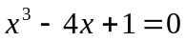 that lies between 1 and 4, correct to three decimal places by using the Newton-Raphson method.  - Use fixed point iteration method to evaluate root of the equation  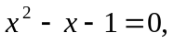 correct up to 3-decimal places. | 8  7
 | - The velocity distribution of the fulid near a flat surface is given below:-  X is the distance from the surface using a suitable interpolation formula, obtain the velocity at x=0.2  - Use the data linearization method and determine the exponential fit of y = C e^{Ax} for the following data: | 8  7
  X(cm) | 0.1 | 0.3 | 0.5 | 0.7 | 0.9
  V(cms) | 0.72 | 1.81 | 2.73 | 3.47 | 3.98
  X: | 0 | 1 | 2 | 3 | 4
  Y: | 1.5 | 2.5 | 3.5 | 5.0 | 7.5
 | - Evaluate the following integral  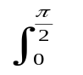 sin x dx  Using  - Trapezoidal Rule  - Simpson's 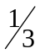 rule  - Simpson's 3/8  Comment on the result.  - Using secant method, find the root of the equation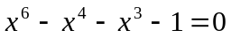. Correct upto 2-significant digit. | 10  5
 | - Monthly faculty salary in three departments of an institute is given below. Assuming that the salary for a particular category is same in all the departments, calculate the salary of each category of faculty. Use any suitable method.  - Use L -U factorization method to solve the following system of equations.  x + y + z = 1  3x + y -3z = 5  x – 2y – 5z = 10 | 7  8
  Department | Number of faculty  Prof. Asst.prof. Lect. | Total in thousands.
  A | 2 2 4 | 60
  B | 3 1 2 | 50
  C | 1 4 3 | 60
 | - Solve y' = y + e^{x}, y(0) = 0 for y(0.2) and y(0.4) by RK-4th order method.  - Use Heun's method to solve y" – xy + 4y = 0;y(0) = 3; y′ (0) = 0 at x = 0.2. Take h = 0.1 | 7  8
 | - In a square bar with dimension of 3 inch × 3 inch, torsion function, , can be obtained from the following P.D.E: 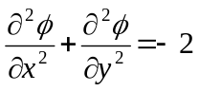 where = 0 on the outer boundary of the bar's cross-section. Subdivide the region into nine equal squares to form a mesh and find the values of in the interior nodes.  - Find the largest eigen value using power method current up to 2-significant digit.  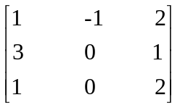 | 10  5
 | Write shorts notes on (Any Two) :  - Ill-conditioned systems  - Shooting method for solving boundary value problem  - Cubic spline | 5×2

